

Thesis methodology

MSc PM A24

Content

- OBJECTIVES OF THE THESIS 5
- THE STRUCTURE OF THE THESIS 6
AUTHOR'S PRESENTATION 10
- APPENDICES 13
- THE 5 KEY STEPS OF THE THESIS 15
STEP NO. 1: PROBLEM IDENTIFICATION 16
Project Definition 16
  - Identify one or more "real" and "serious" problem(s) 17
  - Choose the problem you will study 18
  - Identify the main underlying subject of the studied problem 19
  - Formulate the subject 20
  - Formulate the Research Problem 20
  - Formulate the Research Questions 20
STEP NO. 2: CONSTRUCTION OF THE ANALYTICAL FRAMEWORK 22
Chapter 1: Review of Scientific Literature 22
Quotations: 24
Cited Books 24
Journal Articles 24
Article in a Book 25
Article from a Website 25
STEP NO. 3: DATA COLLECTION 26
(Part 2 Empirical Study, section 1 Data Collection) 26
- Qualitative Study 26
- Quantitative Study 27
STEP NO. 4: DATA ANALYSIS 28
STEP NO. 5: PROPOSAL OF SOLUTIONS 28
Conclusion 28
WRITING THE THESIS: SOME RULES 30
THESIS SUPERVISOR AND FOLLOW-UP 30
WHAT IS PLAGIARISM? 30
- SUBMISSION AND DEFENSE 32
  - Submission of the final thesis 32
  - Practical rules for defenses 32
  - Written evaluation criteria 33
  - Conduct of the defense 34
POINTS OF ATTENTION 34
- BEST THESIS AWARD (only for MBA2 students) 35
- FORMAT AND COVER PAGE 35

This guide aims to provide a reference framework for MSc at ESLSCA Business School Paris as well as their thesis supervisors.
It presents the necessary information on the process and format of the research thesis.
The thesis is the culminating work of your training in MSc at ESLSCA Business School Paris.
A research thesis is a work based on a scientific approach aimed at providing concrete solutions to a problem encountered by an organization, drawing on the most advanced knowledge in management sciences and adhering to a rigorous methodology.
It is a personal work, consisting of approximately 80 pages (+/-10%) for MSc (from the General Introduction to the General Conclusion, i.e., excluding the table of contents, bibliography, and appendices), in which the student must demonstrate thoughtfulness, method, analysis, and synthesis.
(Any excess in the number of pages will be left to the discretion of each thesis supervisor).
The thesis must link theory (theoretical knowledge) and practice by starting from a concrete problem (which can be experienced by the organization in which the student is doing their internship or apprenticeship, or which can be identified from a course, readings of specialized press, etc.)
The student will rely on existing theoretical knowledge (from existing scientific works) to develop their set of hypotheses. They then conduct their "field investigation" (qualitative and/or quantitative) to respond to the central issue of their thesis and identify concrete solutions.
Therefore, the thesis is not merely a simple exercise in describing a problem but rather an argued analysis of it in order to provide justified and relevant recommendations.
A thesis is not:
- An internship report
- A mission report
- A market study
- A consulting activity report

- OBJECTIVES OF THE THESIS
The purpose of the thesis is to provide fresh and objective insights as well as solutions to a concrete and current problem faced by organizations.
This exercise contributes to the development of knowledge in management sciences and also allows students to develop their analytical abilities and critical thinking.
The thesis draws from the professional experiences of the student as well as from academic and professional literature related to the theme studied.
Following this study, the student will be expected to offer managerial and practical proposals useful to the company.
Three major objectives can thus be formulated within the framework of a thesis:
- To meet a professional objective by providing concrete recommendations to the studied company(companies)
- To satisfy a personal interest: the student must be passionate and interested in the theme addressed in their thesis
- To meet an academic requirement by adhering to the standards of the research thesis

To provide solutions to the problem studied, the student may consider different approaches:
- Describe and analyze a phenomenon, a process, or a given situation
- Explain the relationships and causal links that may exist between several concepts or phenomena
- Verify a given theory in a different context and predict its evolution
- Evolve the practices of an organization by proposing solutions and experiments

Whatever the chosen approach and the means implemented, the thesis must provide solutions to a concrete problem by bringing new insights, adding value to the existing knowledge on the studied theme.
In the case of the MSc in Project Management, the thesis aims to show that the student is capable of:
- Structuring an approach,
- Synthesizing your thoughts,
- Developing a broad vision of a logistics system,
- Analyzing its operation,
- Positioning yourself as a responsible manager of an activity or a project
- Implementing functional solutions to improve logistical efficiency
- Measuring your results

This thesis must demonstrate the ability to use the skills and knowledge acquired to address a problem encountered in the exercise of the professional responsibilities of each learner.
- THE STRUCTURE OF THE THESIS
The structure:
- Defines the general framework of the work
- Will evolve throughout the thesis creation process.
Consists of four elements that the student must strictly follow (see detailed plan below):
- The general introduction
- Part 1 dedicated to the review of scientific literature
- Part 2 dedicated to the empirical study
- The general conclusion.

GENERAL INTRODUCTION:
This introduction requires significant effort in terms of:
- Presenting the practical and theoretical contexts
- Justifying the importance of the problem studied with arguments
- Introducing the research problem and questions
- Announcing the structure of the thesis

CHAPTER 1. REVIEW OF SCIENTIFIC LITERATURE
The review of scientific literature focuses on the thesis topic, the main concepts, the possible theoretical currents, the links between the different concepts, etc.
The use of academic sources is crucial (e.g., Google Scholar, EBSCO, CAIRN) ESLSCA students have access to the EBSCO database.
This first step will allow you to build your analytical framework.

To connect to EBSCO:
On the ESLSCA campus:
http://search.ebscohost.com/login.aspx?custid=ns295476&groupid=main&authtype=ip,uid&p rofile=ehost&defaultdb=buh
Copy and paste this link in your browser
This link can be used from the Campus without authentication, and an unlimited number of people can connect at the same time. Automatic connection.

For off-campus connections in France or internationally. You will need to log in through this link:
http://search.ebscohost.com/login.aspx?custid=ns295476&groupid=main&authtype=uid&prof ile=ehost&defaultdb=buh
Copy and paste the link in your browser Here are the login details:
Username: ns295476main Password: lBn[K8

Other options to connect to EBSCO

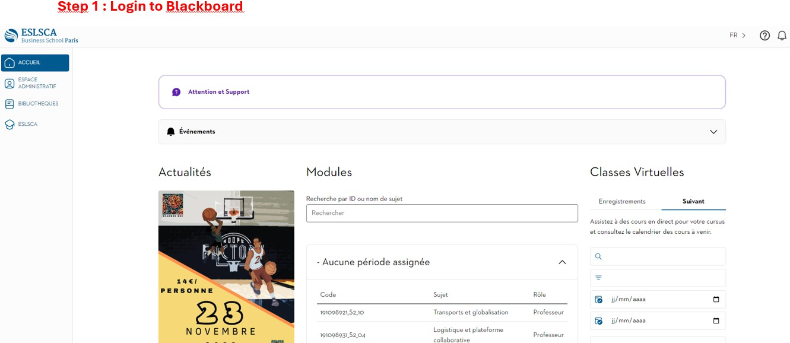

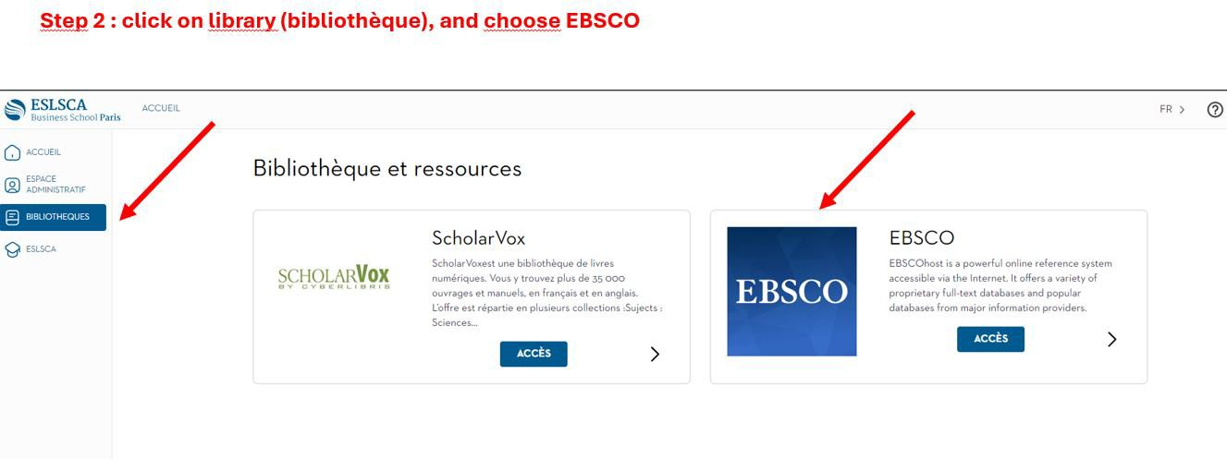

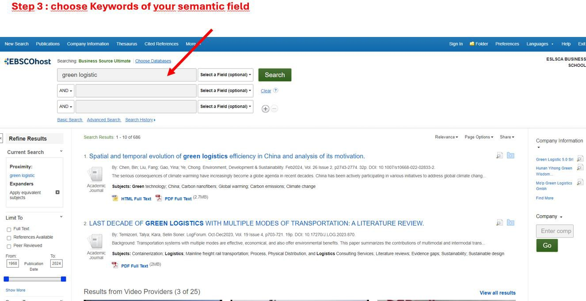
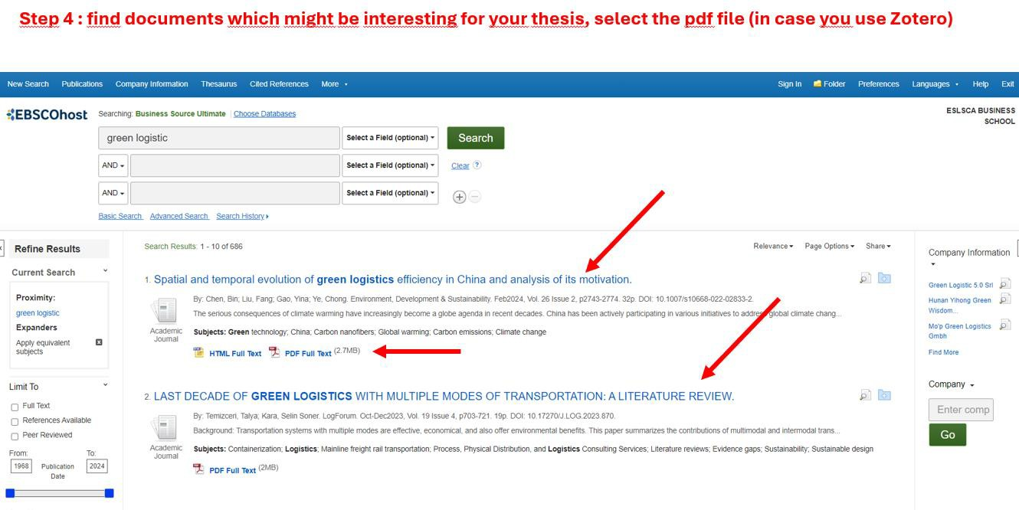

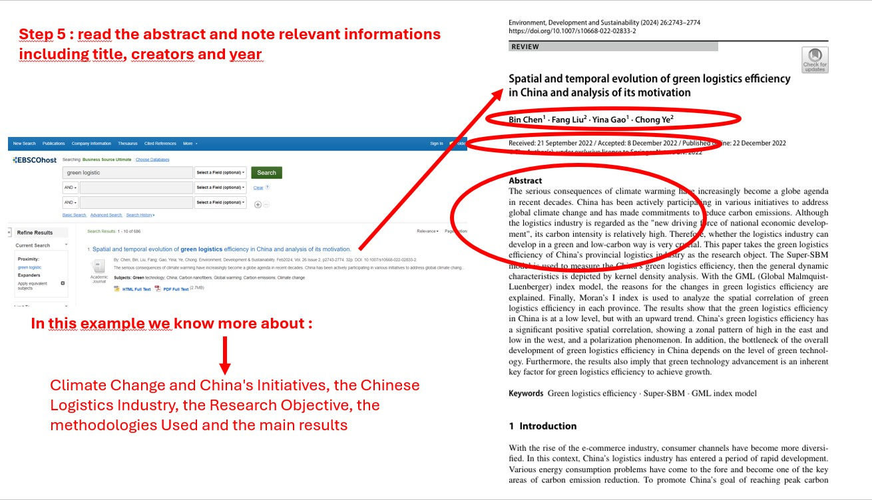
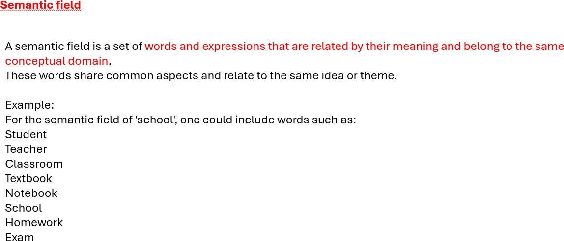

Other options with Google Scholar
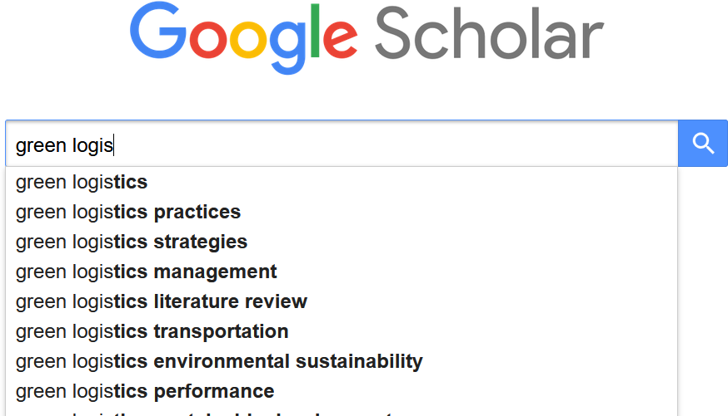

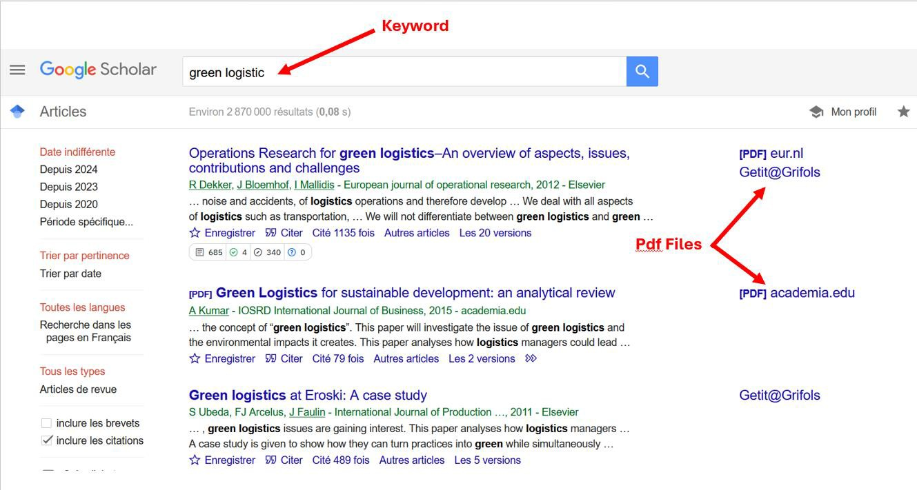

The thesis follows the following structure:
AUTHOR'S PRESENTATION (You)
Maximum 1 page
This section will present the background of each learner to allow readers to understand the profile:
- Professional experience: companies and positions held
- Education: previously completed cycles
The presentation will also include the motivations of each learner for pursuing the MCL program and the contextual elements that seem important.
GENERAL INTRODUCTION PART 1: LITERATURE REVIEW
This first part aims to survey the existing scientific works related to the thesis topic and define the different concepts. Based on this literature review, the student will then explore the potential links/influences between the different concepts to formulate the hypotheses of their model.
Introduction to Part 1
Chapter 1: Title 1 Literature Review
  - Subtitle 1 xxxxxxxx
  - Subtitle 2 xxxxxxxx
Chapter 2: Title 2 Development of a Set of Hypotheses
  - Subtitle 1 xxxxxxxx
  - Subtitle 2 xxxxxxxx

Conclusion of Part 1
PART 2: EMPIRICAL STUDY

General Presentation of the Company
- This first section allows presenting general information about the company, in particular:
- History: creation, evolutions and transformations, current situation
- Mapping: existing physical sites by specialty: production, storage, research, administration, etc.
- Key figures: turnover, number of employees, etc. For all presented figures, you must show the trends over the last 10 years to clarify the current trends.
- Structure: legal, managerial [executive committee, organization], identification of shareholders
- Products: what the company does [manufacturing, processing, assembly, etc.], its market outlets [who are the clients, where are the products sold/shipped, etc.]
Competitive Environment
The company is positioned in one or more markets. It faces competitors. This part should show how the company manages these aspects.
- Sector[s] of activity: what are the company's sectors of activity? What is the current dynamic of these sectors [growth, contraction, etc.]?
- Competition: identification of the main competitors, evaluation of market shares among the main competitors, competitive strategy, etc.
- Regulation/regulation: are there regulatory impacts on the markets/sectors of the company's activities? If so, which ones? What are the impacts on the company's organization?

Logistics Organization
- The logistics organization of a company is a major lever in its ability to face its competitive environment. Present the elements showing how the company has structured its logistics organization:
- E2E Supply Chain: in a form combining diagrams and descriptions, present the physical flows of the company, from its suppliers to its customers, including its transformation stages.
- Logistics organization: how has the company structured its logistics direction [organizational chart?], with roles and responsibilities of the parties, but also showing the relations with other directions [cross-management]
- Logistics process: from order taking to customer delivery, what are the stages of the logistics process? What are the information systems used to carry out/control the processes?
- Performance, maturity & challenges: is the current organization performing [indicators – dashboards]? What is its maturity [use the results of the Supply Chain Master audit]? What are its main challenges for the coming years?

This second part deals with the empirical investigation: your field survey. It is structured as follows:

Introduction to Part 2
Chapter 3. Data Collection and Analysis Methodologies
  - Study Context: presentation of the organization studied, sector of activity, stakes
  - Followed Methodology: possible documentary analysis, qualitative and/or quantitative study
Chapter 4. Results, Discussion, and Contributions Here, the aim is to answer the research questions.
  - Obtained Results: thematic analysis of the collected data and answer to each research question
  - Discussion: comparison between the obtained results and the existing scientific literature, perspective on the contributions of the work done to the scientific literature
  - Contributions: the student will need to formulate concrete proposals/recommendations for companies to "solve" the posed problem.
Conclusion of Part 2.
GENERAL CONCLUSION
This conclusion will:
- Summarize the answer to the research problem
- Present the limitations and future research directions.

BIBLIOGRAPHY:
All references read, consulted, and used during the thesis work must be listed. Each time an author's text is cited or paraphrased,
- it must be cited in the body of the text as follows: (Falcone, 2020) : (Creator(s), Year)
- then included at the end in the bibliographic references according to APA standards as follows:
o Falcone, P. M. (2020). Environmental regulation and green investments: The role of green finance. International Journal of Green Economics, 14(2), 159-173.
To manage the bibliography you can use software like Zotero (free) and connect it to Word : this is not mandatory but might be usefull.
https://www.youtube.com/watch?v=M2wsGCqavPI&list=PL4asXgsr6ek5H5mM9GlA1d- YCb9KvP3Ja


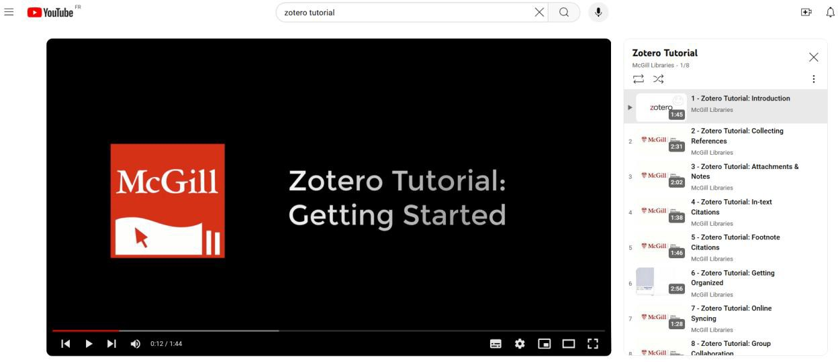

APPENDICES
The appendices should include:
- The interview guide
- The questionnaire

All interviews that have been transcribed (if qualitative methodology was used)

Principles of text transcription:
All elements mentioned by the interviewee must be written down, in the appendices, and even if there are mistakes in the respondent's language, you must meticulously note these mistakes.
It is possible to transcribe automatically using software like MS Teams, Google Speech to Text, or Word.
As a guideline, 20 minutes of interview represent about 8 to 9 pages of a Word document.
Once the transcriptions are completed, you will need to conduct a study of the verbatims used, noting the points of convergence and divergence among the interviewees.
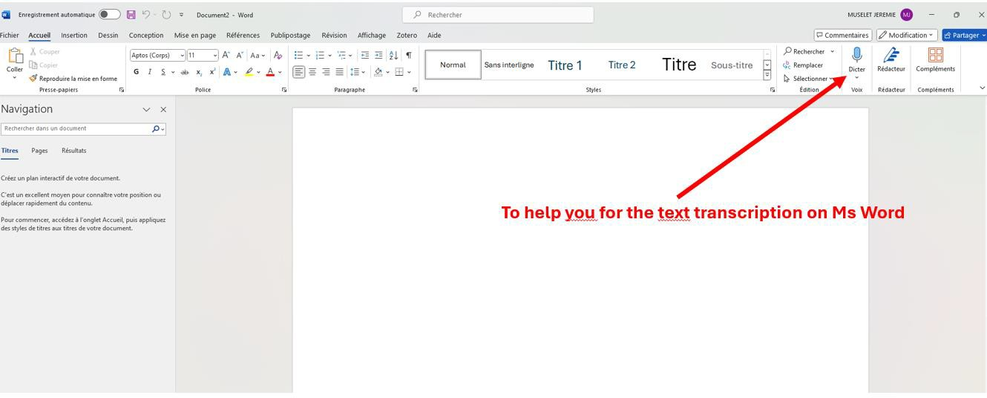

- Additional results (Mapping, Verbatim Table, other SPSS outputs, SmartPls)
- The list of figures. Each figure must have a number and a title (e.g., Figure 1: Evolution of XXXXX 2010-2020);
- The list of tables. Each table must have a number and a title Similarly (Table No. 1…)
- Other appendices.

REMINDER:
Each chapter of the thesis must include:
- An introduction to link with what precedes and to announce what follows
- A conclusion to summarize the main lessons of the chapter and to link with the rest of the document.

THE 5 KEY STEPS OF THE THESIS
To give you more guidance on the process of completing your Thesis, the diagram below presents the 5 major steps to follow to complete this work.
These 5 steps are spread throughout the development of the thesis (Step 1: Identification of the problem, Step 2: Construction of the analytical framework…):
GENERAL INTRODUCTION
Step 1. PROBLEM IDENTIFICATION
→ Identify a concrete and significant problem, translate it into a research problem and three research questions.

CHAPTER 1 - REVIEW OF SCIENTIFIC LITERATURE
Step 2. CONSTRUCTION OF THE ANALYTICAL FRAMEWORK
→ Build your analytical framework based on a review of scientific literature.

CHAPTER 2 – EMPIRICAL STUDY Step 3. DATA COLLECTION
→ Collect the necessary secondary and primary data to answer your research questions.

Step 4. DATA ANALYSIS
→ Answer the research questions based on a rigorous analysis of the collected data.

Step 5. PROPOSAL OF SOLUTIONS
→ Address your research problem by proposing solutions aligned with the results of the data analysis.

GENERAL CONCLUSION

STEP NO. 1: PROBLEM IDENTIFICATION
Project Definition

Approximately 3 to 5 pages
- This section should present the origin of the project assigned to you by the company: why the company is facing a problem, the benefits it hopes to gain from your mission, and the objective set for you.
  - Context: assessment of the situation at the time the company asks you to take on the project or the reason why you choose this topic. Presentation of the dysfunctions encountered at the origin of your project and the expectations of the sponsor.
  - Objectives and stakes: by entrusting you with the project, the company has at least one objective, each objective [if there are several] can be broken down into one or more stakes. You need to report these elements. It is strongly advised to verify the definition of what an objective and a stake are to fully understand the expectations.
  - Problem statement: this is the statement of the encountered problem.
    - It starts with a complete diagnosis of the scope of the mission entrusted, which allows validating that the problem to be addressed is identified, measured, validated.
    - Depending on the situations, the diagnosis may lead to interviews with concerned actors within the company. The summary of the interviews must confirm the diagnosis.
    - The problem statement allows you to formulate your subject precisely. It leads to the formulation of the question to be solved. The problem statement is at the junction between the definition of the subject and its treatment. It provides all the elements that allow understanding the problem, contextualizing it, and treating it correctly.
    - Thus, the problem statement must:
      - Uncover all potentialities, i.e., all the elements and interactions to consider and to understand how the question arises.
      - Indicate in which direction(s) the answers or solutions may be found.
    - The construction of the problem statement is done in a back-and-forth work between the first idea of the subject and the deepening of its context while generating questioning. The development of the problem statement proves that you know how to analyze and understand a problem and that you know how to formulate a question.
  - Recommendations: Recommendations are a proposed solution to the posed problem that is accepted before being subjected to the test of experience.
    - At this stage of your work, you do not know if the proposed solution(s) will produce the expected effects and will achieve the targeted objectives.
Thus, do you propose to explore one or more solutions knowing that only experimentation will confirm, invalidate, or qualify the advanced hypotheses. Establishing a SWOT analysis on your recommendations is interesting to anticipate the strengths/weaknesses and threats/opportunities of the proposed solutions.
(General Introduction of the thesis)

Experience has shown that conducting a thesis without starting from a specific problem and disconnected from the real stakes of companies generally does not lead to relevant and quality work.
Therefore, identifying the problem must be the 1st step of the research thesis. Practical advice:
- Identify one or more "real" and "serious" problem(s)
Identifying a "real" and "serious" problem from reading or in the organization where the internship/apprenticeship is carried out thus constitutes the starting point of the thesis work.
This problem must be:
  - "Real": meaning it corresponds to a reality for organizations (e.g., in which the student is doing their internship/apprenticeship.
  - "Serious": meaning it is significant enough to merit in-depth study for several months in advance.
In clear terms: the student must be able to demonstrate that this problem is relevant on empirical (something that interests organizations) and theoretical (a gap in existing scientific works) levels.
If this is not the case, it is better to choose another one. What is a problem?
A problem is a situation that presents a short-to-medium term danger for an organization or the sector on which the study will focus.
There are 3 types of problems:
  - Dysfunction: it is something that does not work/anymore in the Organization and needs to be "repaired" quickly (example of a car: an engine breakdown).
  - Ineffective or inefficient operation: something that works poorly/is not optimized and could be improved (example of a car: a poorly tuned engine that runs but not as fast as usual).
  - A threat to the future short-to-medium term operation: something that ultimately threatens the proper functioning of the organization and that will need to be better managed.
This could be the emergence of a danger related to an internal or external change/shock that could have significant consequences on the organization (example of a car: an oil leak that does not prevent the car from running for the moment...).
In summary, to identify a problem, start by asking the following questions:
  - What is the origin of the dysfunction?
  - What are the improvement paths?
  - What must be absolutely controlled/curbed?
  - What needs to be improved, repaired, or controlled as a priority?

WARNING:
It is necessary to identify "concrete managerial problems" and not "imaginary" or too "abstract" problems that would not have a real existence within the Organization or the sector under study.
To avoid falling into the trap of a problem that is too "macro" or too "broad," it is always necessary to start from very concrete "micro-problems" (at the scale of your job, team, department), that is, problems actually experienced by field actors.
If these "micro-problems" are too limited and/or not "important/serious" enough to dedicate a thesis to, you will always have the possibility to group them to retain a broader, more relevant problem.
Example of a Luxury Brand Thesis topic:
"The impact of e-commerce on the marketing of luxury products"
A student doing their end-of-studies internship in a luxury company notices that implementing e-commerce is complicated. Yet, it is strategic for luxury brands to be able to integrate this new channel as their longevity depends on it (which fully justifies the choice to write a thesis on this problem).
  - Identification of a "real" problem: this corresponds to actual adaptation difficulties encountered by luxury brands.
  - Identification of a "serious" problem: it threatens the brand's longevity, the quality of service offered, and its promotion.

- Choose the problem you will study
Once the main "real" and "serious" problems encountered by your organization (related or not to your internship/apprenticeship) are listed, you will then need to choose the one you will work on in the context of your thesis. This choice must be dictated by several elements:
The relevance of the problem to your professional project:
Will working on solving this problem allow you to develop expertise, knowledge useful for your professional project, your job search in the short to medium term?
The feasibility and access to data:
Early on, the student must be able to assess the temporal constraints and access to information sources to study the problem in question.
This means asking whether it will be possible to have access to reliable and relevant information, to conduct interviews...
The state of practical knowledge and research on the issue:
Some themes and subjects are already widely explored. In this case, it is important to know if you can bring new knowledge to existing works.
If the subject has not been extensively worked on, you will need to evaluate the quantity and quality of available information before getting started.

Revisiting the example of a Luxury Brand Thesis:

"The impact of e-commerce on the marketing of luxury products"
Relevance: the student who has chosen this problem wishes to work in digital in the luxury sector.
Feasibility: by doing their internship in a luxury group, the student will have the opportunity to collect data from current and possibly former collaborators and may also interview actors from the luxury world outside the company.

- Identify the main underlying subject of the studied problem
Once the problem is chosen, you must be able to identify the underlying concepts. This step is essential to properly "launch" your MFE because it is the central notion around which your scientific literature review will be conducted.
Advice:
  - Concepts are generally contained within the identified problem.
Ask yourself what the problem is about, what does not work, what could be improved, what risks being negatively impacted in the short/medium term.
  - It is a central concept for the studied problem and also universal (detached from the sectoral, organizational context...).
For example, if your study focuses on problems related to the deployment of GDPR (General Data Protection Regulation) in your organization, your central subject will not be the deployment of GDPR, but the "universal" category to which GDPR deployment belongs.
It will therefore be "the deployment of a new standard within an organization."
Consequently, always ask yourself to which universal category the problem you seek to solve belongs.
  - The identified subject must be clearly formulated.
Ask yourself if the terms used are correct, precise, targeted, sufficiently encompassing without being too broad.
NB: your thesis director will help you refine the scope of this theme as well as your readings (upcoming scientific readings).

Example of a Luxury Brand Thesis topic:
"The impact of e-commerce on the marketing of luxury products"
It is normal for the precise formulation of the main theme studied in the thesis to be refined over the student's readings.
However, it is fundamental to seek to identify this main theme early on (even if it is not final) to give direction to your work and avoid dispersion, which can be a source of frustration and demotivation.

- Formulate the subject
Formulating the subject allows for the formulation of the thesis topic intended to describe the study that will be conducted.

Taking the previous example of the Luxury Brand Thesis, this gives: "The impact of e-commerce on the marketing of luxury products"

- Formulate the Research Problem
Following this, comes the moment to "Formulate your research problem," meaning the main question addressed in the context of your end-of-studies thesis, the answer(s) to which will constitute concrete solutions to solve the studied problem.
Example: Luxury Brand Thesis
Research Problem: How to integrate the e-commerce channel into the go-to-market strategy of a luxury brand?
The research problem boils down to asking: "What solutions can be provided to the studied problem?".
It is advised to use the interrogative form "How..." to formulate it (as in the examples above).
Example 1: Luxury Brand Thesis
= Objective/Title of the thesis: Integrating the e-commerce channel into the go-to-market strategy of a luxury brand
This is the best way to keep the objective of your thesis in focus throughout the process.

- Formulate the Research Questions
Finally, it involves breaking down this research problem into research questions (3 to 5) (the number of research questions will be set in agreement with your thesis director).
The research questions:
  - Correspond to the questions you need to ask yourself to be able to answer the research problem of your thesis.
  - Allow describing, understanding, and/or explaining the studied problem.

Four major elements can be apprehended to describe, understand, and explain the studied problem:
- Motivations and barriers.
- Behaviours.
- Attitudes/perceptions (judgments/beliefs, emotions)
- Resources at work (tools, skills, methods/processes)

Research questions for the example of the Luxury Brand Thesis:
  - What are the characteristics of e-commerce in luxury brands?
  - How do the leaders of these structures perceive the integration of e-commerce into their go-to-market strategy?
  - How is the integration of e-commerce experienced by the employees?
  - What are the elements that positively and negatively impact this integration process?

STEP NO. 2: CONSTRUCTION OF THE ANALYTICAL FRAMEWORK
Chapter 1: Review of Scientific Literature
The literature review is essential for any end-of-studies thesis project.
During the preliminary phase of determining the studied problem (and thus the underlying concepts as well as the corresponding subject), each student must start from the concrete problems encountered in their company and research to confirm the relevance of the problems and better delineate the concepts underlying the chosen problem.
This justification must appear clearly in the introduction of the thesis by referring to the sources.
Note: at this stage, it is also relevant to remove the interrogative form of the research problem to simply formalize the central objective of your thesis (which will also be the title of your thesis and will always start with an action verb):
Tip: Once the research problem is identified, deduce the title of your thesis and fill in the cover page of your MFE (see the model at the end of this guide), specifically the title area.
In the introduction, sources should primarily be "professional" to justify the empirical relevance of the topic; and "academic" to justify the theoretical relevance of the topic.
Practical sources should provide precise and ideally quantified data to quantify the "magnitude" of the problem. This can include press articles, white papers, and professional studies (INSEE, XERFI, Financial Markets Authority, BPI France, COFACE) or works by recognized professional experts.
Academic sources are used to justify the theoretical relevance of the topic but also to conduct the "Review of Scientific Literature" in part 1. This part will include a more in-depth approach around key concepts associated with the main theme addressed in the thesis. The goal is to synthesize existing academic knowledge on the studied theme in order to formulate the model's hypotheses.

Therefore, an analysis of reference scientific articles on the chosen theme is a necessary step. Possible sources include:
  - Scientific articles (EBSCO)
  - Scientific articles (Google Scholar)
  - Academic books
  - Conference proceedings (AIMS, AFM, AGRH, AFC, AIM, etc.)
The review of scientific literature must be conducted with rigor and method.

It is preferable to systematically write reading notes that will easily retrieve the following elements:
  - Title, author, journal, year
  - Theme and keywords
  - Main ideas and connection with the studied problem

In summary:
Non-scientific sources can be used at the beginning of the thesis (mainly in the introduction) to justify the practical relevance of the studied problem.
The ability to justify the choice of the studied problem is indeed fundamental in the thesis exercise at the beginning of the document.
The scientific literature review (part 1) must rely on academic, scientific sources (articles from scientific journals mainly) to rigorously define the concept(s) used and design an analytical framework that is as objective and precise as possible.
This framework will then serve as a backdrop for conducting the empirical study.
When the student refers to authors in the body of the text, the collected information must be synthesized and reformulated.

Quotations:
Any textually quoted borrowing must be placed in quotation marks and accompanied by a complete reference:
  - Author's name
  - Date
  - Page.
Similarly, any borrowing of an idea must be accompanied by a complete reference. Words belong to everyone, that's clear, but sentences belong to their authors.
The arrangement of ideas, their composition, and their expression are what are protected. Quotations must exactly match the original text.
The author is responsible for their accuracy.
If they are short (1 to 3 lines), insert them into the text, in quotation marks.
If they are longer (more than 3 lines), set them apart from the text, indicated by an indent on the left, a space before, and a space after, without quotation marks and the references in parentheses.
Finally, all quotations in foreign languages can be translated, with the original possibly appearing in a footnote.
All bibliographic references must be included in an appendix and presented according to the current standards:

Cited Books
Last name, first initial. (year), Title of the book, Place of publication, Publishing house.

Example:
Burt, S. R. (1992), Structural Holes, the Social Structure of Competition (italicized), Cambridge, MA, Harvard University Press.

Journal Articles
Last name, first initial. (year), "title of the article", Name of the Journal (italicized), vol., no..., p...

Example:
Burt, S. R. (1995), "Social Capital, Structural Holes, and the Entrepreneur", French Review of Sociology, vol. 36, no. 4, p. 599-628.

Article in a Book:
Last name, first initial. (year), "title of the article", in: Name of the author(s) of the book, Title of the book (italicized), Place of publication, Publishing house, pages.

Example:
Bidault, F. and Jarillo, C. (1995), "Trust in Economic Transactions", In: F. Bidault, P.-Y. Gomez, and G. Marion (eds), Trust, Business, and Society, Paris, Eska, p. 109-123.

Article from a Website:
Last name, first initial. (year), "title of the article", Name of the Journal (italicized), vol., no..., p..., website address, date of access

Example:
SAPORTA, B. (2003), "Theoretical Preferences, Methodological Choices, and French Research in Entrepreneurship: A Provisional Assessment of Work Undertaken Over Ten Years", Review of Entrepreneurship, vol. 2, no. 1, p. V-XVII. http://asso.nordnet.fr/r- e/RE0201bs.pdf accessed on 10/05/2009.

STEP NO. 3: DATA COLLECTION
(Part 2 Empirical Study, section 1 Data Collection)
Two main methodologies are possible for data collection.
These are the qualitative approach and the quantitative approach. Far from being opposed, these two approaches are complementary. The student may choose to use one or both of these approaches.
Note that it is quite rare for a quantitative approach to be used alone without a preceding qualitative approach.
Always keep in mind that the choice of methodology is always "dictated" by the research questions the student seeks to answer, which will, in turn, help find solutions to the thesis problem.
Very pragmatically, it is often the reality of the field (access or not to certain information and certain samples of interlocutors) that guides the chosen methodology.
You should be aware of this early enough to adapt your research questions or even your problem statement in advance. It is obviously pointless to formulate a problem statement for which you cannot provide answers due to lack of access to adequate information.

- Qualitative Study
Qualitative studies aim to understand a phenomenon in depth.
Several techniques can be used to collect qualitative information: semi-structured individual interviews, focus group interviews, experimentation, and observation.
The interview guide should follow a funnel logic.
The interview guide should be included in the "Appendices" section of the thesis and not in the methodology section.
The analytical framework that you will have formalized at the end of your "Chapter 1 Review of Scientific Literature" constitutes a relevant backdrop for structuring your interview guide.
The qualitative study can cover one or several case studies.

A minimum of 10 interviews is required for each case study.
Interviews must be fully transcribed and analyzed manually or with a content analysis tool.
The duration of an interview is about 20 minutes, and this interview must be recorded: it is necessary to ask for the person's consent at the beginning of the recording. At the end, you will need to upload all your interviews to a drive folder accessible to any examiner.
All collected information must be analyzed according to the content analysis method.
The goal is to identify the main themes and detail them while providing illustrations based on the coding of verbatim (interview excerpts).
In the appendix, you must include a Google Drive link to prove that you have conducted these recordings and interviews.

- Quantitative Study
A quantitative study can be conducted separately or in addition to a qualitative study. It allows measuring and quantifying behavior,
a phenomenon, or attitudes.
Students must follow the rules for sample constitution and questionnaire drafting seen and applied in the thesis methodology course.
Data analysis will be performed using SmartPls software. Failure to comply with this rule will result in a penalty for the student. The most effective solution is the use of a Google Form
Surveys or interviews that need to be conducted will be done with the necessary rigor. The prior validation of interview guides and/or questionnaires by the thesis director is necessary.
Any consultation or request for authorization deemed necessary by the student from the company's or organization's hierarchy under study is left to the student's discretion and responsibility.
The entire approach deployed (qualitative/quantitative approach, interviewed persons, asked questions, data analysis method) must be described in detail in a "data collection" section (followed methodology). Several pages should be devoted to this part.
The graphs should be included in the appendix; only your analysis should be in the main body of the report

STEP NO. 4: DATA ANALYSIS
Data analysis aims to present the main elements of the answer to the research questions, in a precise and argued manner, and to show the contribution of the obtained results to the existing knowledge ("Discussion").
"For qualitative studies, it is not about "copy-pasting" the transcribed interviews.
Students will present the main themes addressed in the interview guide by interpreting the obtained statements.
The outputs ("mapping", tables) and excerpts from the interviews "verbatim" must be included in the section related to "Obtained Results" to illustrate each addressed theme.
"For quantitative study", you are asked to present the main results according to the hypotheses.
Regardless of the adopted methodology, the goal is to provide answers to the research questions "Obtained Results". The results are the answers to your research questions, and the thought process should not stop at presenting the results.
A "confrontation" phase between the obtained results and the existing theoretical knowledge will highlight the contribution of your work to the knowledge within the "Discussion" section. It is about demonstrating how your study enriches the existing scientific literature.

STEP NO. 5: PROPOSAL OF SOLUTIONS
Finally, the Proposal of Solutions section aims to answer the thesis problem. It involves proposing relevant and argued solutions to the studied problem.
The student will rely on the obtained results to identify and imagine the most suitable solutions to the problem encountered by the Organization.
Additionally, the student may rely on professional literature (manuals, general public books, white papers, etc.) to identify solutions, if they select "serious" sources, cite the used sources, and justify the relevance of the chosen solutions in relation to the study's results.

Conclusion
Between 2 and 5 pages
The conclusion wraps up the project. It is structured into three parts consisting of a general conclusion, contributions and lessons learned, and the limitations and future prospects of the work carried out.

General Conclusion The general conclusion:
- Recalls the initial objectives and the methodology used.
- Presents the main results as an answer to the posed question.
- States the key success factors and the obstacles to overcome.

- Describes the conditions for applying the used method in other companies or environments.

Contributions and Lessons Learned
Personal contributions or ideas should be highlighted to facilitate the reader's appreciation of the work accomplished.

Limitations and Future Prospects
A critical analysis of the adopted approach and the obtained results should be presented to identify limitations. It should also suggest openings for further work.

WRITING THE THESIS: SOME RULES
Some principles must be followed when writing the thesis:
- Avoid "I", use "we" instead;
- Be precise, concise: eliminate anything that is not essential for the topic and the demonstration.
- Engage the reader from the start.
- The plan for each chapter should never exceed THREE sections.
- Subdivisions should be sufficiently numerous, clearly indicated, and hierarchized.
- The author's interventions in the text of a quotation (deletion, addition, or replacement of words or letters) must be indicated in brackets: Text cut: […] / Modification took[ing] / Comments: [it is here about] or [it is we who emphasize]
- Do not hesitate to summarize at the end of each chapter: what has been learned? Where is the demonstration at? Has progress been made?
Plagiarism.
Fraud means sanction!
- All research theses will be checked by plagiarism software
The tolerance threshold is 10% (of quotations), and any work exceeding this rate will receive a final grade of 00/20.
It is therefore recommended to formulate the main ideas, continuously cite the sources used, and resort as little as possible to quotations.
- No automatic retake
The case of students who have not passed their MFE will be reviewed by the degree awarding jury which takes place in December.

THESIS SUPERVISOR AND FOLLOW-UP
Each student must have a thesis supervisor. It is MANDATORY to submit your thesis project to your Program Director to have a thesis supervisor.

WHAT IS PLAGIARISM?
Plagiarism: comes from the Latin plaga which meant the condemnation to whipping of those who had sold free men as slaves (cf. Voltaire's Philosophical Dictionary).
"One could call plagiarist, all the compilers, all the makers of dictionaries, who do nothing but repeat wrongly and across the opinions, errors, impostures, truths already printed in previous dictionaries; but at least these are plagiarists in good faith; they do not claim the merit of invention."
Plagiarism is the word-for-word repetition of a sentence from a text without citing sources; in other words, it is a copy and it is a copyright infringement offense.

To plagiarize is to borrow someone else's words or ideas without mentioning the name and/or without putting the borrowed words in quotation marks. In other words, it's stealing someone else's words, ideas, or statistics and passing them off as your own.
Similarly, partial or total translation of others' texts constitutes a form of plagiarism if the source is not indicated. Thus, plagiarism is considered by law as fraud since you pretend something false to be true to gain a personal advantage.
Examples: copies of documents found on the Web, complete pages of a book, or an article from a magazine or newspaper.
The thesis supervisor is responsible for accompanying the student and guiding them in their reflection. Each student will need to contact their thesis supervisor as soon as they are assigned.

Throughout the thesis process, milestones will be set, and the thesis supervisor must validate each of the 5 steps described in this guide.

Each student must contact their thesis supervisor and continuously exchange on the Black Board platform throughout the thesis period, so that all requested documents are uploaded to the platform according to the schedule.

Additional exchanges can be made via Teams and by phone.

A penalty of one point on the overall thesis grade will be applied for each missed deadline for submitting the expected elements on Black Board.

The thesis supervisor's role is not to chase after students but to guide and help them produce work that meets the required academic standards.

In the final phase of the process, each thesis supervisor will be responsible for assessing the quality of the submitted thesis during a jury composed of 2 people.

Be mindful of the summer period, during which your thesis supervisors might be on vacation.

- SUBMISSION AND DEFENSE

- Submission of the final thesis
The deadline for thesis submission is set according to the table below. No additional time can be granted for submission.

Any late submission for steps 1 to 5 will result in a penalty of 0.5 points.

  - Step 0:
- Submission of topics: Mid-August 2025
  - Step 1:
- Submission of the problem statement and beginning of literature review to justify it end of September
  - Step 2:
- Complete literature review with research hypotheses and draft plan end of October
  - Step 3:
- Methodological choices for fieldwork (sample, data collection method) at the end of November
  - Step 4:
- Methodology of analysis, results, and first managerial recommendations + final and validated plan + limitations on the 15th of January 2026
  - Step 5:
- Final submission of the thesis on the 1st of Feb 2026

- Practical rules for defenses
All submitted theses deemed defendable (written grade >= 10/20) will be subject to an oral defense.

An invitation will be sent to you following the submission of your thesis and its plagiarism analysis, provided that your thesis supervisor does not advise against the organization of the defense.

The submission of the final thesis on Black Board does not mean that the written document is validated and worth 10/20.

The overall evaluation of the thesis is based on both the written work (60%) and the oral presentation (40%).

The final grade must be equal to or greater than 10/20 to validate the thesis.

Note that validating the thesis after defense (minimum 10/20) is among the conditions for obtaining the degree.

If the thesis is not validated, the student will not graduate.

The total duration of the defense is:
- 40 minutes (the first 20 minutes are dedicated to the student's presentation of their work without interruption from the jury)

A PowerPoint or Canva document is mandatory for any thesis defense.

During the presentation, the student will discuss their topic, context, problem statement, a brief synthesis of the literature review on the topic, methodology, results, recommendations, and limitations of their work.

You will not be asked to present work different from what was done in the thesis.

Following this presentation, the jury will ask any questions they deem necessary.

After a short deliberation, the jury will then provide feedback to the student on the strengths and weaknesses of their written and oral work.

Evaluation grids are provided to the thesis supervisor and jury members.

- Written evaluation criteria
- Identification of the problem (problem, research question, research questions);
- Relevance of the plan
- Relevance of the literature review
- Interest and relevance of the hypotheses

- Rigor in data collection
- Use of data analysis tools
- Results (answers to research questions and the problem statement) and discussion
- Managerial contributions
- Exchanges with the thesis supervisor via Black Board
- Style and spelling.
The presentation must convince the jury members by presenting the main points of the thesis.
Particular emphasis should be placed on the empirical part as well as on the added value of your work.

- Conduct of the defense : expected between the 2nd of March and the 6th of March 2026
Total duration of 40 minutes:
- 20 minutes of presentation of your work
NB: For theses with a written grade below 10/20, there will be no oral defense,
- 10 minutes of exchange with the jury
- 5 minutes of jury deliberation
- 5 minutes of debriefing.

POINTS OF ATTENTION
- Present a number of slides between 12 and 15;
- Use slides that are not too "busy" but contain relevant content;
- Number the slides;
- Look at the audience;
- Have a professional attire;
- Do not read from your notes;
- Respect the allotted time;
- Qualify your statements and avoid being radical in judgment;
- Check the spelling of your presentation;
- Use various means to make the presentation original and dynamic;

- BEST THESIS AWARD
The best thesis award will be given to the work that most meets the academic requirements requested both in writing and orally.
Only one prize will be awarded per class.
The concerned student will be rewarded during the graduation ceremony.

- FORMAT AND COVER PAGE
Each thesis must adhere to the common presentation standards:
Writing standards:
  - Times New Roman / Font size 12;
  - Margin 2.5 cm on the left / 2.5 cm on the right;
  - Line spacing 1.5 pt;
  - Mandatory pagination;
  - No right alignment;
  - Footnotes for clarification or citation. Cover page (see next page):
  - ESLSCA Paris logo;
  - Final thesis (Bold, 16)
  - Academic year;
  - Thesis title (Bold, 18); Name of the student and their program (14); Name of the thesis supervisor (14).
Summary:
  - Cover page;
  - Blank sheet for corrector's annotations;
  - Mandatory declaration to be included in the thesis, duly signed and dated
  - Acknowledgments (if necessary);
  - Glossary/list of abbreviations (if necessary);
  - Abstract in French + keywords (≈400 words);
  - Abstract in English + keywords (≈400 words);
  - Table of contents;
  - General Introduction;
  - Text of the thesis organized into two chapters;

  - General Conclusion;
  - Standardized bibliography;
  - List of figures and annexes with page indications;
  - Annexes/appendices

